# Data analyst roles and job descriptions

As technology continues to advance, being able to collect and analyze data from that new technology has become a huge competitive advantage for a lot of businesses. Everything from websites to social media feeds is filled with fascinating data that, when analyzed and used correctly, can help inform business decisions. A company’s ability to thrive now often depends on how well it can leverage data, apply analytics, and implement new technologies.

This is why skilled data analysts are some of the most sought-after professionals in the world. A study conducted by IBM estimates that companies in the United States will fill 2,720,000 Data Science and Analytics jobs by 2020*. Because the demand is so strong, you’ll be able to find job opportunities in virtually any industry. Do a quick search on any major job site and you’ll notice that every type of business from zoos, to health clinics, to banks are seeking talented data professionals. Even if the job title doesn’t use the exact term “data analyst,” the job description for most roles involving data analysis will likely include a lot of the skills and qualifications you’ll gain by the end of this program. In this reading, we’ll explore some of the data analyst-related roles you might find in different companies and industries.

* *“The Quant Crunch: How the Demand for Data Science Skills is Disrupting the Job Market,” by Will Markow, Soumya Braganza, and Bledi Taska, with Steven M. Miller and Debbie Hughes.* [*https://www.ibm.com/downloads/cas/3RL3VXGA*](https://www.ibm.com/downloads/cas/3RL3VXGA)

## Decoding the job description

The data analyst role is one of many job titles that contain the word “analyst.”

To name a few others that sound similar but may not be the same role:

* Business analyst — analyzes data to help businesses improve processes, products, or services
* Business intelligence analyst — analyzes data for finance or market insights
* Data analytics consultant — analyzes the systems and models for using data
* Data engineer — prepares and integrates data from different sources for analytical use
* Data scientist — uses expert skills in technology and social science to find trends through data analysis
* Data specialist — organizes or converts data for use in databases or software systems
* Operations analyst — analyzes data to assess the performance of business operations and workflows

Data analysts, data scientists, and data specialists sound very similar but focus on different tasks. As you start to browse job listings online, you might notice that companies’ job descriptions seem to combine these roles or look for candidates who may have overlapping skills. The fact that companies often blur the lines between them means that you should take special care when reading the job descriptions and the skills required.

The table below illustrates some of the overlap and distinctions between them:

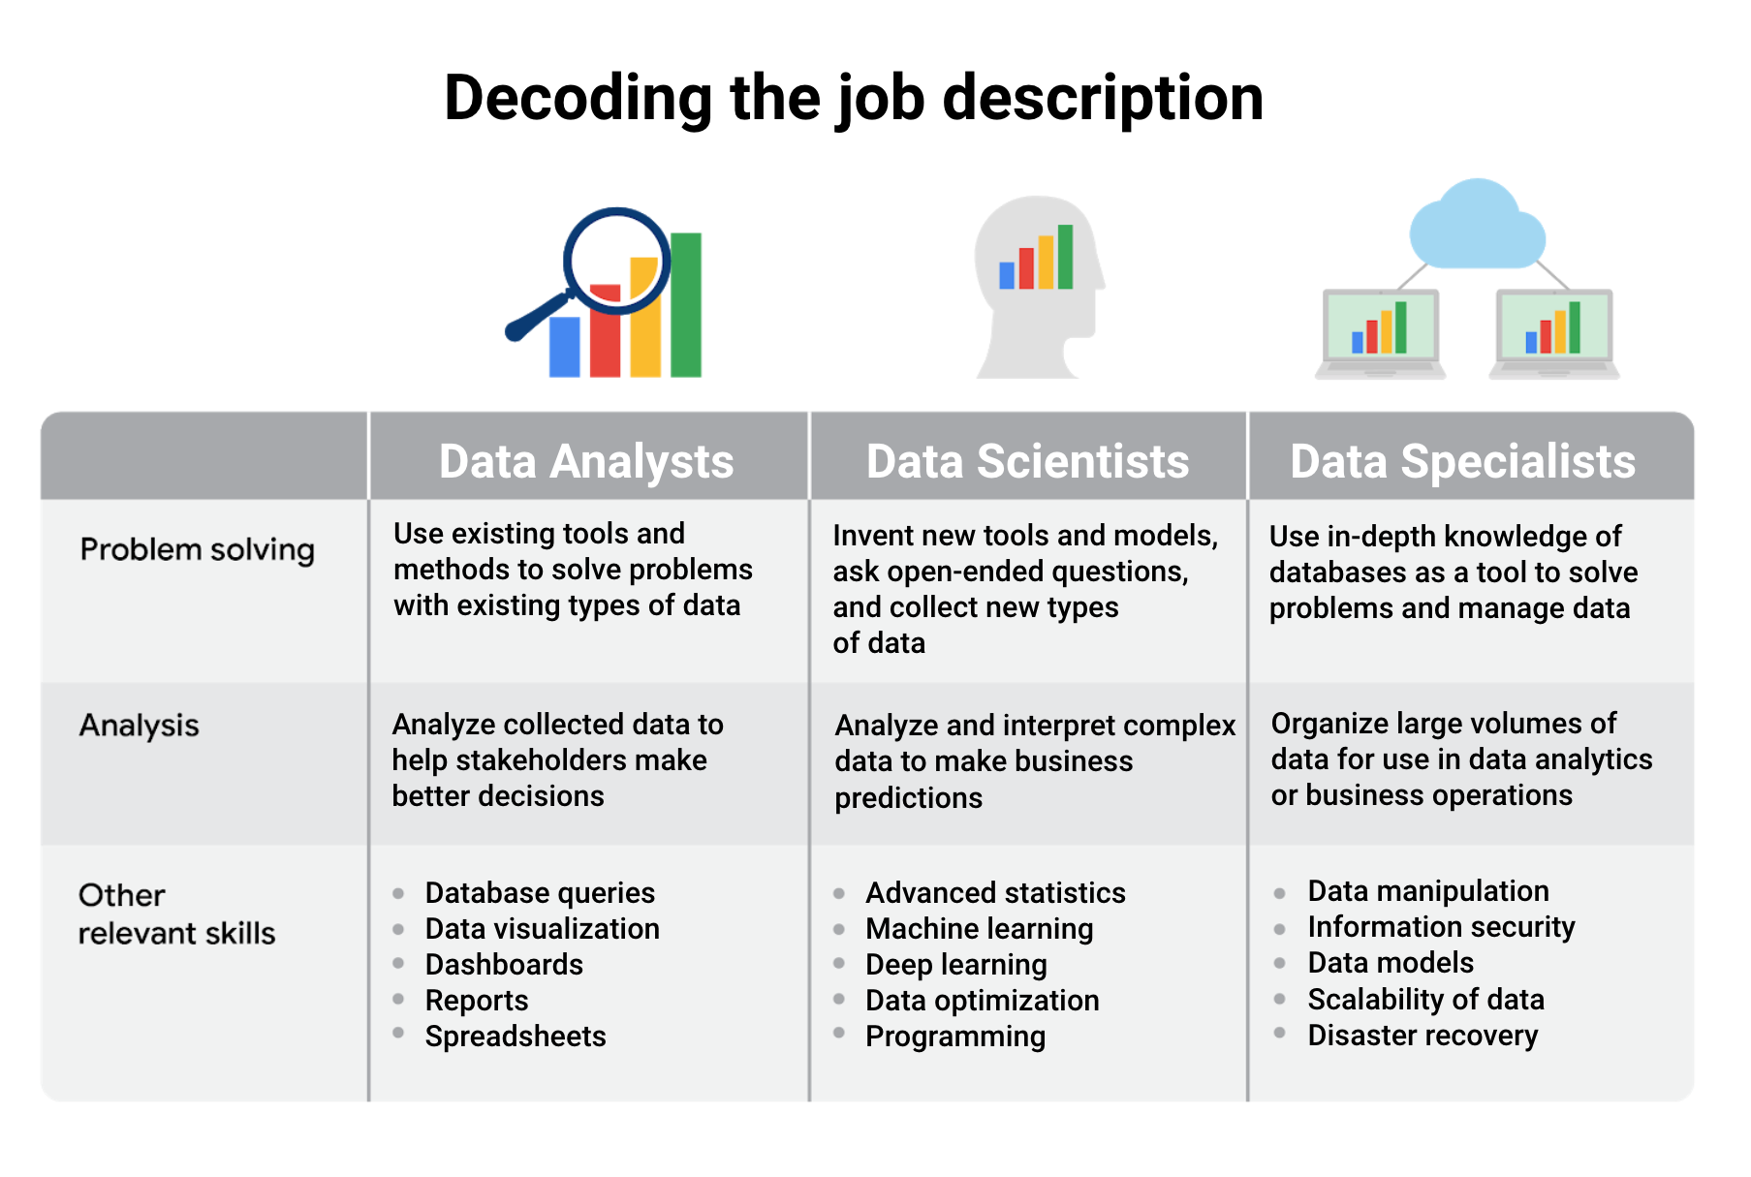

Title: Decoding the job description

data analysts:

-problem solving: Use existing tools and methods to solve problems with existing types of data

-analysis: Analyze collected data to help stakeholders make better decisions

-other relevant skills: database queries, data visualization, dashboards, reports and spreadsheets

data scientists:

-problem solving: Invent new tools and models, ask open-ended questions,

and collect new types

of data

-analysis: Analyze and interpret complex data to make business predictions

-other relevant skills: advanced statistics, machine learning, deep learning, data optimization, and programming

data specialists:

-problem solving: Use in-depth knowledge of databases as a tool to solve problems and manage data

-analysis: Organize large volumes of data for use in data analytics or business operations

-other relevant skills: data manipulation, information security, data models, scalability of data, and disaster recovery

We used the role of data specialist as one example of many specializations within data analytics, but you don’t have to become a data specialist! Specializations can take a number of different turns. For example, you could specialize in developing data visualizations and likewise go very deep into that area.

## Job specializations by industry

We learned that the data specialist role concentrates on in-depth knowledge of databases. In similar fashion, other specialist roles for data analysts can focus on in-depth knowledge of specific industries. For example, in a job as a business analyst you might wear some different hats than in a more general position as a data analyst. As a business analyst, you would likely collaborate with managers, share your data findings, and maybe explain how a small change in the company’s project management system could save the company 3% each quarter. Although you would still be working with data all the time, you would focus on using the data to improve business operations, efficiencies, or the bottom line.

Other industry-specific specialist positions that you might come across in your data analyst job search include:

* Marketing analyst — analyzes market conditions to assess the potential sales of products and services
* HR/payroll analyst — analyzes payroll data for inefficiencies and errors
* Financial analyst — analyzes financial status by collecting, monitoring, and reviewing data
* Risk analyst — analyzes financial documents, economic conditions, and client data to help companies determine the level of risk involved in making a particular business decision
* Healthcare analyst — analyzes medical data to improve the business aspect of hospitals and medical facilities

## Key takeaway

Explore data analyst job descriptions and industry-specific analyst roles. You will start to get a better sense of the different data analyst jobs out there and which types of roles you’re most interested to go after.